**Abstract Instructions & Templates**

**Table of Contents**

Please use the information in this Word docx file to prepare your abstract. Pages 3 and 4 serve as templates,

**Instructions for Abstract Preparation 2**

These instructions apply to   
- trainees who wish to present a talk or a poster, and   
- everyone else wishing to present a poster

*Note: PIs who were previously invited to speak in platform sessions have already received separate Abstract Instructions from the Organizers.*

**Sample for Abstract by Authors in 1 group 3**

The sample text includes excerpts from the Wikipedia entry for Josiah Willard Gibbs.

**Sample for Abstract by Authors in many groups 4**

The sample text includes excerpts from the Wikipedia entry for Josiah Willard Gibbs.

**Example of printing poster abstracts in 2x2 layout 5**

A 4-per-page format will be used in the Program Book distributed at the conference to save space and costs.

*Please consider advertising job openings and training programs on Poster Board #1 in each Poster Session (Sunday & Monday evenings). No abstracts needed.*

*Bring your brochures, ads, QR codes, etc.*

**Detailed Instructions for Abstracts  
for Trainee Talks and All Posters**

**Space limitations & Confidentiality**

Poster abstracts will be printed 4 per page in the Program Book.  
*The last page of these instructions shows format*  
They will **not** be publicly available online.

We recommend limiting text to 150 to 200 words depending on the amount of text needed for the title, authors and affiliations.

Figures (black/white) are welcome but must be accommodated within the allowed space.

**Text Parameters**

Margins: 1" on all sides

Line spacing: Single, with one blank line between  
(a) title & authors, and (b) authors & abstract body.

Font: Arial (except for special characters)

**Title Font: Arial 20, Bold**

Authors, Affiliations and Body of Text: Arial 18

Underline presenting author(s)

References must be self-contained in body text (e.g., Zhang et al, *Science* (2023) VV:PP). No footnotes.

**Abstract Submission**

During the application, you will submit your abstract in 2 formats (i.e., upload 2 files)  
a. a Word DOCX file for final formatting  
b. a PDF file for reference to show special characters

Name the abstract files as follows:

PresenterLastName\_PresenterFirstName\_LastNamePI

Abstracts that exceed the space allotted will be truncated. Truly.

**Page 3 Use Arial 20 Bold for Abstract Title**

Arial18 Student A, Postdoc B, RA C, PI D

Dept. of Biochemistry and Molecular Biophysics,   
Washington Univ. in St. Louis, St. Louis, MO 63110

Use Arial 18 for text with 1" margins on all sides. Underline presenting author(s). Sample shows how ~140 words will fit with a short address and a small figure with legend. Gibbs was born in New Haven, Connecticut. He belonged to an old Yankee family that had produced distinguished American clergymen and academics since the 17th century. He was the fourth of five children and the only son of Josiah Willard Gibbs Sr., and his wife Mary Anna, *née* Van Cleve. On his father's side, he was descended from Samuel Willard, who served as acting President of Harvard College from 1701 to 1707. One of his ancestors was the Rev. Jonathan Dickinson, the first president of the College of New Jersey (later Princeton University). Gibbs's given name derived from his ancestor Josiah Willard, who had been Secretary of the Province of Massachusetts Bay.

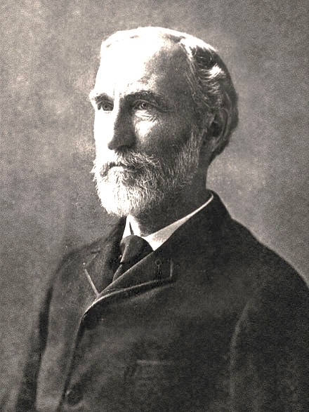

The Gibbs Program Book will be printed in black & white. You are welcome to include figures as long as they fit within the 1" margins. If a legend is included, please use Arial14 for the text. Anything smaller will be unreadable by many once the abstract is reduced to quarter-page size.

**Page 4 Use Arial 20 Bold Title for Abstract Title**

Arial18 Postdoc A1, Postdoc B2, PI C2, PI D1,  
Dept. of C, Univ. of X, New York, NY 10065 and   
Dept. of E, Y Univ., Baltimore, MD 21218  
Affiliations for different departments at multiple universities will occupy a lot of space and limit the body of the abstract or space for a figure. We recommend that you condense where possible so that you identify persons A and B at University X and person D at University Y but omit building address(es) for each one of them. Do abbreviate "Department" as Dept. and "University" as Univ..

Use Arial 18 for text with 1" margins on all sides. Underline presenting author(s). Sample is ~100 words. Gibbs was born in New Haven, Connecticut. He belonged to a family that had produced distinguished American clergymen and academics since the 17th century. He was the 4th of 5 children and only son of Josiah Willard Gibbs Sr., and his wife Mary Anna, née Van Cleve. He was descended from Samuel Willard, who served as acting President of Harvard College from 1701 to 1707. One of his ancestors was the Rev. Jonathan Dickinson, the first president of the College of New.

The Gibbs Program Book will be printed in black & white. You are welcome to include figures as long as they fit within the 1" margins. If a legend is included, please use Arial14 for the text. Anything smaller will be unreadable by many once the abstract is reduced to quarter-page size.

MAS_BSB_HD:Users:shea:Desktop:Gibbs38_Instructions_&_Sample_Abstracts_for_AllPosters_and_TraineeTalks_2024_final.pdf